Arch Dam coffee table review
Y-CJ44-L · Large · RC-T01 Rev 01
Status: technical clarification required before approval.
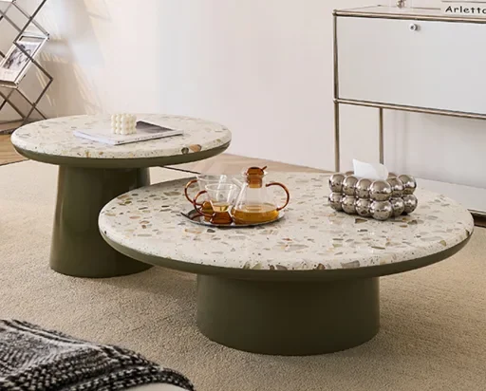
Selected item: large foreground table only. Small background table and styling objects are excluded. Do not derive dimensions from the photograph.

Overall source dimensions
90 × 100 × 30.5 cm
Shown as width × depth × height. Confirm dimension order, tolerances and exact outline on a supplier drawing. The PDF includes an illustrative envelope, not manufacturing geometry.
Source: fictional Qimu Living Demo, Living Room Series, A110:J111.

Materials and review sign off
Terrazzo surface · sample code pending
Solid wood frame · species pending
Piano-gloss lacquer · finish code pending
Ivory surface and warm gray-green base in fixture

Questions blocking approval
Confirm overall dimension order and tolerances.
Provide terrazzo and lacquer samples with codes.
Confirm edge profile, assembly and maintenance.
Provide project-specific performance evidence if required.
No load rating, fire classification or certification is established. RC-T01 is an internal reference, not a manufacturer finish code.
Reviewed by __________________ Date __________
Decision _____________________ Revision ______

