Bashi floor lamp
BASHI-LAMP-TALL
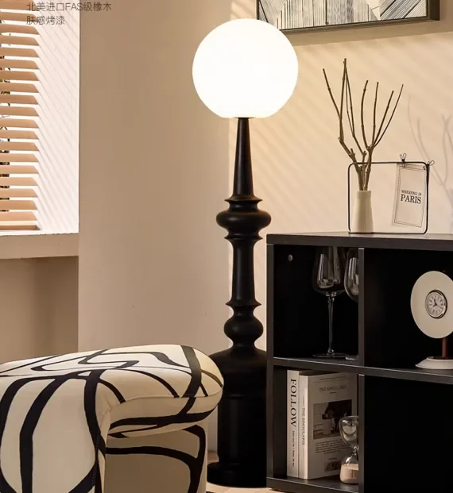

A sculptural black form
A globe shade above a turned profile. Tall configuration shown in the supplied Demo image.
Ø 60 × H 138 cm · Imported oak · Black tactile lacquer · Opal globe shade
Source radius 30 cm converted to diameter 60 cm. Light output, bulb specification and electrical compliance are unconfirmed.
Fictional Demo · Living Room Series A129:J130 · Rev 01. Project image is included for this example; no image license is transferred.

