Reading corner product comparison
Brief RC-01 · Black frame · W ≤ 50 cm · D ≤ 55 cm · Demo budget ≤ CNY 700
Three source configurations. All amounts are fictional Demo prices. Dimensions are W × D × H; comfort and seat heights remain unverified.
Black Woven Chair  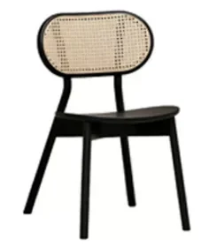  H-YZ02  48 × 54 × 81 cm  Demo CNY 690  Black lacquer; woven cane back  RETAIN FOR REVIEW  Black finish and 48 cm width meet the brief. Open frame is visible; comfort remains untested.  Source row A123:J123 | Vintage Conversation Chair  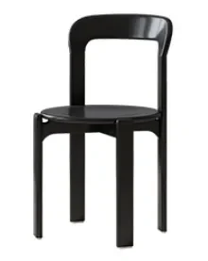  Y-CY07  40 × 40 × 80 cm  Demo CNY 630  Imported oak; black lacquer  CONFIRM BEFORE CHOOSING  40 cm width leaves more space. Confirm seat height and a seated trial before choosing for reading.  Source row A120:J120 | Thonet Cane Chair B  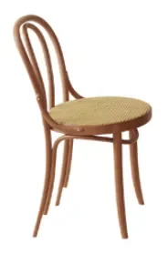  Y-CY03  36.5 × 43 × 90 cm  Demo CNY 560  Imported beech; cherry finish; cane  EXCLUDE THIS FINISH  Dimensions and Demo budget pass. Cherry finish fails the black-frame requirement; no black variant is documented.  Source row A119:J119
Decision record: retain the woven chair for review; confirm the compact conversation chair for reading use; exclude the documented cherry-finish Thonet option. No automatic score is assigned.
Reviewer __________________ Date __________ Brief revision __________

